**Chapter 10**

Dornbusch, Fischer and Startz: *Macroeconomics*

**IS Curve**

**1. Definition**

The **IS curve** is **defined** as a locus of points showing alternative combinations of Y and r such as (r0, y0), (r1, y1), (r2, y2) which ensure commodity (product) market equilibrium. Any point on the **IS curve** implies product market equilibrium because at each such point I = S.

**2. Derivation of IS curve**

The equilibrium in the goods market depends on the interplay of aggregate demand (expenditure) and income. In a closed economy, aggregate demand is the sum of personal consumption expenditures (C), investment (I) and government spending (G):

AD = C + I + G

Consumption (C) depends on disposable income which equals autonomous spending (c0), spending that occurs even at zero income, plus the product of marginal propensity to consume (c) and disposable income. Disposable income equals total income (Y) minus taxes (t).

Investment (I) depends on interest rate. If the interest rate is low, investing in new capital is cheaper and hence investment spending is higher.

Equilibrium in the goods market occurs when expenditure equals production. It is graphically represented by the Keynesian cross which is the graph of expenditure and output level.

Figure c) shows the investment function. It shows that as the interest rate rises from r1 to r2, investment declines from I1 to I2.

In Figure a), the decrease in investment shifts planned expenditure downward, decreasing income from Y1 to Y2.

Figure b) shows that the higher the interest rate, the lower the lower the level of output.

Y
AE
Y I
r r
1
I1I2Y1Y2
Y2 Y1
AE
Planned expenditure
c) The investment function
a) The Keynesian cross
b) The IS curve
r2
...

**3. Slope of IS curve**

The IS curve is negatively sloped because a higher level of the interest rate reduces investment spending, thereby reducing aggregate demand and thus the equilibrium level of income.

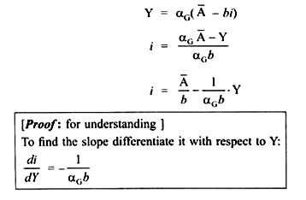

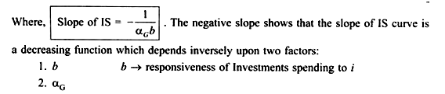

The steepness of the curve depends on how sensitive investment spending is to changes in the interest rate, and also on the multiplier. If investment spending is very sensitive to interest rate, then a given change in the interest rate produces a large change in aggregate demand, and thus shifts the aggregate demand curve up by a large distance.

A large shift in the aggregate demands schedule produces a correspondingly large change in the equilibrium level of income. If a given change in the interest rate produces a large change in income, the IS curve is very flat. This is the case if investment is very sensitive to changes in interest rate. On the opposite, if the investment spending is not much sensitive to changes in the interest rate, the IS curve is relatively steep.

Now, we already know that changes in investment spending bring about changes in income depending upon the value of multiplier. If investment spending is very sensitive to changes in interest rate, the value of multiplier is large and hence the change in income is also large which leads to flattening of the IS curve. On the opposite, if the investment spending is relatively insensitive to changes in the rate of interest, the IS curve is steep because of the lower value of the multiplier.

**4. Shift of IS curve**

Shift in IS curve is due to (a) change in Autonomous spending (A) with interest rate constant or (b) change in taxes

**[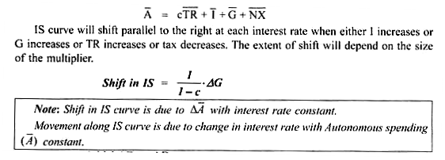](http://cdn.economicsdiscussion.net/wp-content/uploads/2014/12/image93.png)**

Assume: Initial AD → AD1

Autonomous spending → A

interest rate → i1

goods market is in equilibrium at point E1 because Y = AD at point E1

Equilibrium output level → Y1

Thus, point E1 corresponds to a point on the IS curve (IS0)

If Autonomous spending increases to A1 for e.g.

due to increase in I at a given interest rate → i1, firms plans to invest more,

or due to increase in government expenditure the IS curve will shift to the right from IS0 to IS1.

As investment is a component of AD, increase in investment at a given interest rate i1 will lead to shift in AD curve.

.**.**. AD curve shifts parallel upwards to AD2

Y = AD at point E2 at same interest rate → i1

.**.**. Income level increases to Y2

Point E2 corresponds to a point on the new IS curve (IS1)

IS shifts horizontally by distance = αG.∆A or αI ∆ A

Thus, due to increase in A, the IS curve shifts to the right.

However, the change in income due to ∆A will depend on the value of multiplier.

**[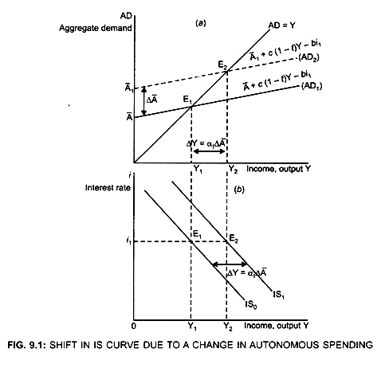](http://cdn.economicsdiscussion.net/wp-content/uploads/2014/12/image94.png)**